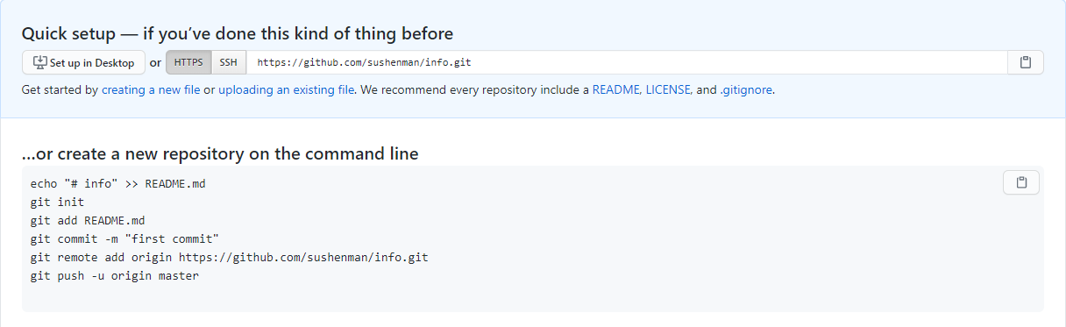Uploading process screenshots

1. Creating a new repo

2.Uploading files through Git bash

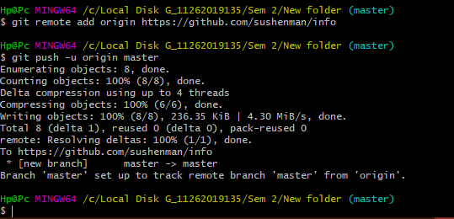

3. Checking the file ni the git hub.

